IOT ASSIGNMENT - 1

LINK FOR DEMO VIDEO:

<https://youtu.be/qHxK9uX2C2U>

CIRCUIT CONNECTION:

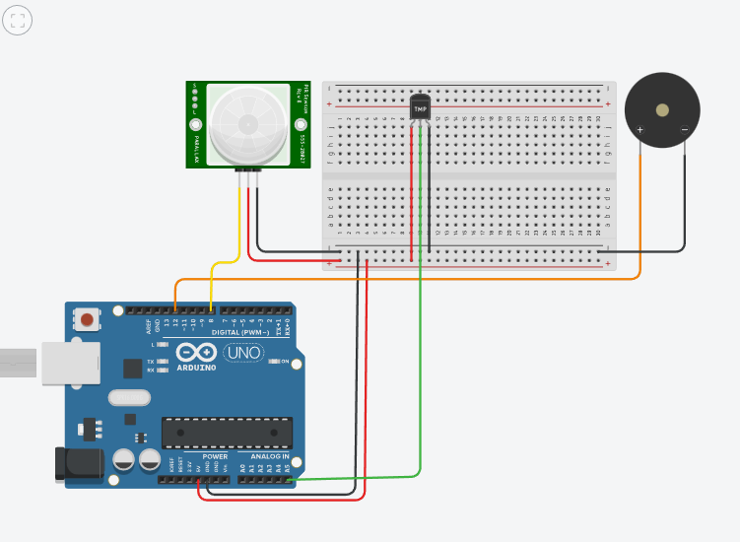

BUZZER START BEEPING WHEN TEMPERATURE GREATER THAN 60 DEGREES:

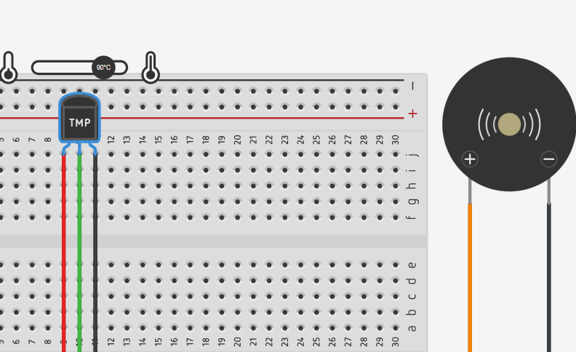

BUZZER STARTS BEEPING WHEN ANY MOVEMENT OF AN OBJECT IS DETECTED BY PIR SENSOR:

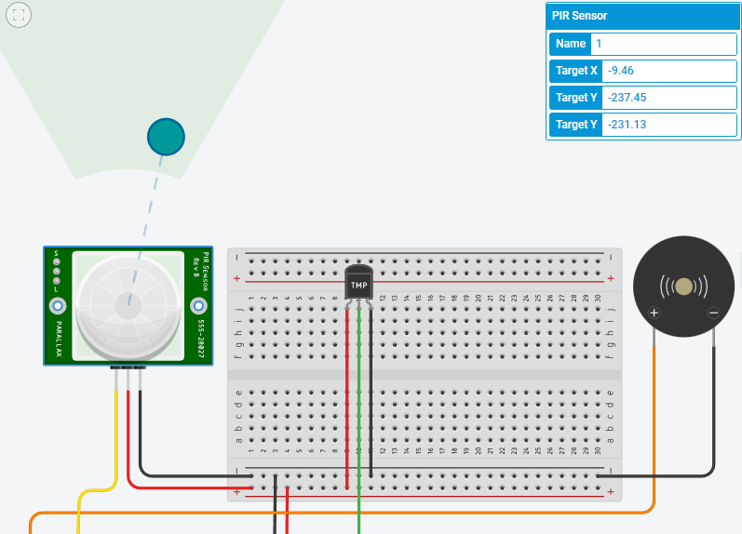

CODE FOR ASSIGNMENT:

void setup()

{

Serial.begin(9600); //baud rate

pinMode(12,OUTPUT); //set D12 as output(From Arduino To buzzer)

pinMode(8,INPUT); //set D8 as Input(From PIR sensor to Arduino)

}

void loop()

{

{

double data=analogRead(A5);

double n=data/1024;

double volt=n\*5; //because connected to 5v

double off=volt-0.5;

double temperature=off\*100; //offset value

Serial.print("Temperature data: "); //printing Current Temperature

Serial.println(temperature);

if (temperature <= 60)

// When temperature is greater than 60 then the buzzer start's beeping

{

digitalWrite(12,LOW);

}

else

{

digitalWrite(12,HIGH);

delay(500);

digitalWrite(12,LOW);

delay(500);

}

}

{

int motion=digitalRead(8);

if (motion==1){

Serial.println("Motion is Detected ");

digitalWrite(12,HIGH);

delay(5000);

}

else{

Serial.println("No Motion");

digitalWrite(12,LOW);

}

}

}

// THANK YOU //